Footpath Closure - Alternative Route
Key: Temporary access via Bridleway 8.
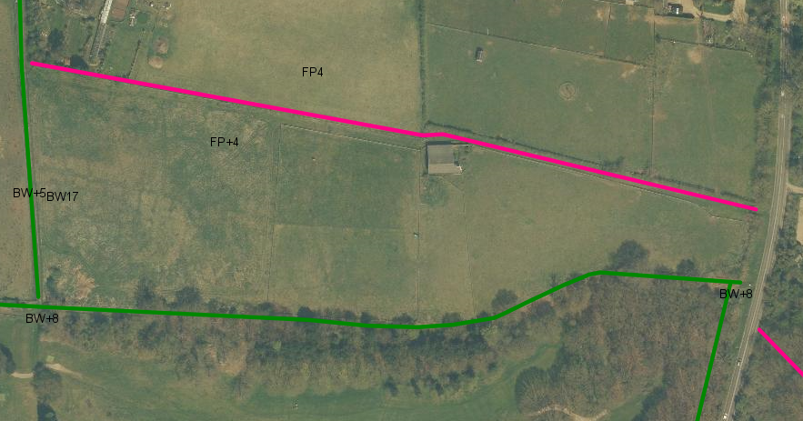
For further information please contact Christopher Dorow Rights of Way Officer – Tel 0300 3006906

